**Forecasting**

**Example- Plastic Sales**

**Dataset contains 60 observations and 2 variables with Sales is our target variable.**

**No missing values and outliers are present in our dataset.**

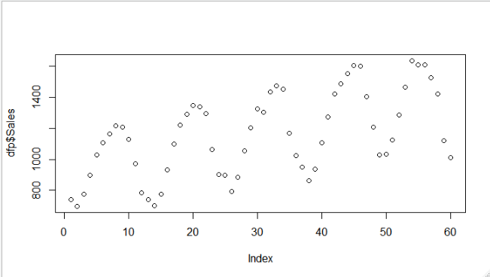

**From the above plot sales is in purely cyclic is nature, with weak sign of tradeline in sales data.**

**Data Preprocessing 🡺**

**Created dummy variables from 1949 to 1953 for all the months.**

**Considered first 40 records as train data and balance 20 records as test data.**

**Linear Trend Model 🡺**

**Multiple R-squared: 0.1211, Adjusted R-squared: 0.09802**

**RMSE 🡺 248.924**

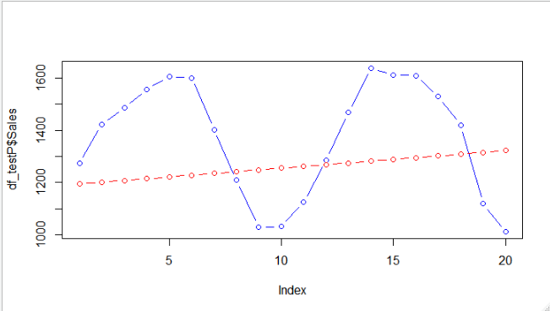

**From the above plot predicted values are not in cyclic pattern in our data.**

**Exponential Model 🡺**

Multiple R-squared: 0.1269, Adjusted R-squared: 0.104

RMSE 🡺 250.1071

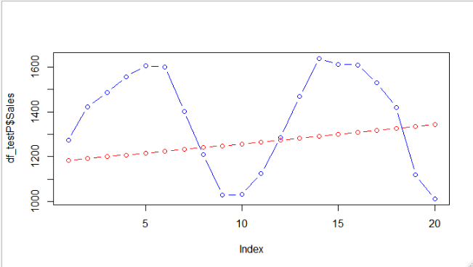

**There are no changes in this model as compared to previous model.**

**Model to Capture Seasonal variation 🡺**

**Multiple R-squared: 0.8405, Adjusted R-squared: 0.7778**

**RMSE 🡺263.2362**

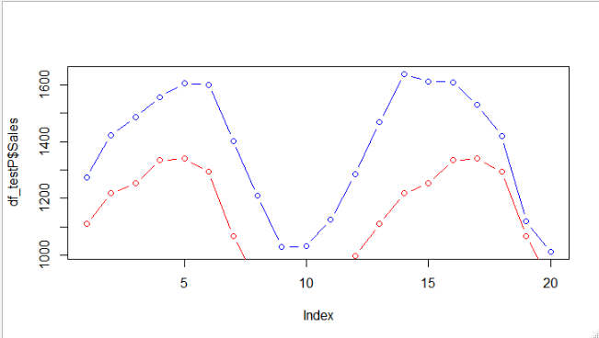

**From above plot pattern of actual values is followed by predicted values and**

**Sales is completely depending on seasonal changes.**

**Additive Seasonality with Linear Trend 🡺**

**Multiple R-squared: 0.9791, Adjusted R-squared: 0.9698**

**RMSE 🡺 105.2468**

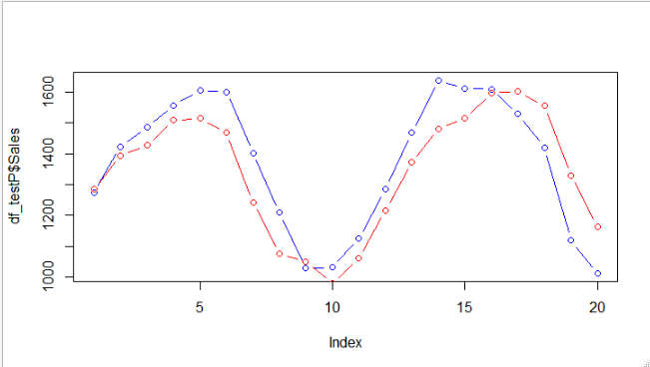

**In this plot gap between predicted and actual value is compressed as compared to previous model.**

**Multiplicative Seasonality 🡺**

**Multiple R-squared: 0.9848, Adjusted R-squared: 0.9781**

**RMSE 🡺 117.115**

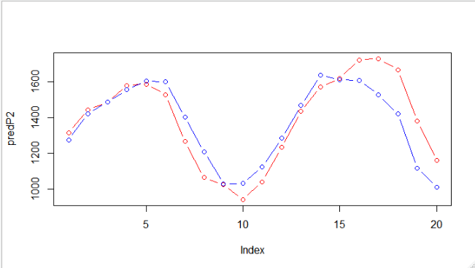



**In this plot slight problem with last 5 records because difference in**

**quite noticeable.**

|  |  |  |
| --- | --- | --- |
| **Model** | **R^2** | **RMSE** |
| **Linear Model** | **0.1211** | **248** |
| **Exponential Model** | **0.1211** | **248** |
| **Model to Capture Seasonal variation** | **0.8405** | **263.2362** |
| **Additive Seasonality with**  **Linear Trend** | **0.9791** | **105.2468** |
| **Multiplicative Seasonality** | **0.9848** | **117.115** |

**From above plots and table, we can infer that Additive Seasonality**

**with Linear Trend Model is our best final model.**